We have reviewed the
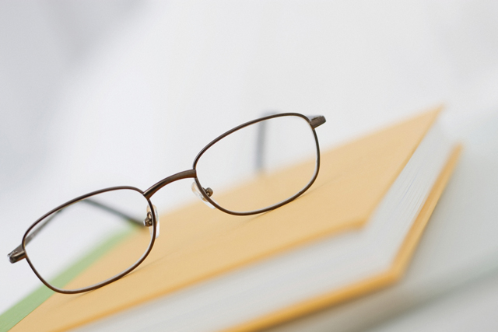

Lin-Wood Handbook AND

are aware of its Contents.

Date:__________

___________________________

Parent/Guardian Signature

___________________________

Student Signature

Please Print student’s name here:___________________

We, parents/guardians/students are responsible for all school property
issued to our child(ren) included but not limited to:
books, calculators, laptops, uniforms.

Please review the handbook ASAP, tear out this form
and return it to your HOMEROOM teacher!

Please do this by October 1, 2012

